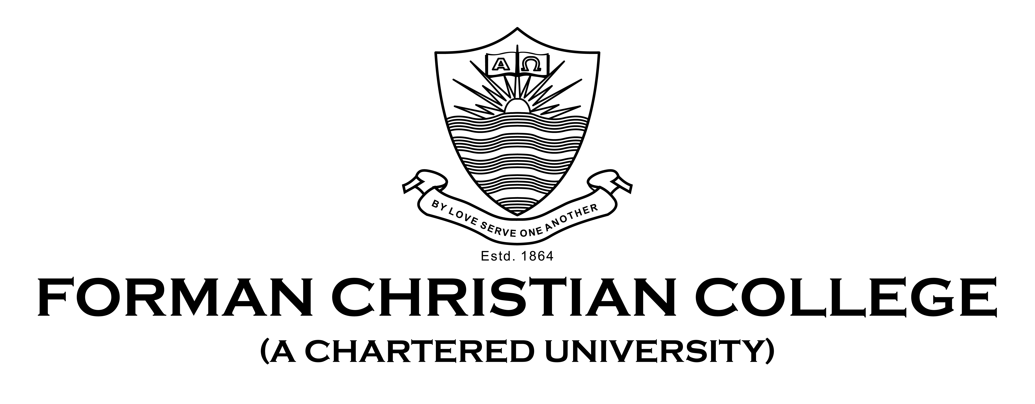

Name: Huzaifa Khaliq

Roll #: 231459085

Course: Technology Management CSCS 450 A

Instructor: Sir Saad Bin Saleem

Assignment 1

Technology management is described as a subject, closely related to the IT Management, which allows the organizations to manage their technological essentials to attain the strategic growth by taking the client benefit.

IT Operations Management(ITOM) is the managerial area which involves the technology base and the requirements of the individual services or the applications within the organization. It includes all the processes which are controlled by the IT department. ITOM ensures the availability, competence and functioning of the organization’s procedures and customer services.

Information Technology Service Management includes the activities of the organization from designing and building to delivering and controlling the IT services that are provided to its customers. In simple words, IT Service Management (ITSM) is stated to the final delivering of the IT services to its customers.

IT Asset Management is the term used for the method of verifying that the organization’s assets are appropriately recorded, installed, retained, and disposed of at the required time. This type of management is done just to make sure that valuable assets are used in the organization and are being followed.

Talking about the relationship of ITSM & ITOM, the functions of both types of management are overlapping to a great extend as both play their part in ensuring the consistency and efficiency of the IT service delivered to its client. However, there is a small difference between these two and that is due to the approach both types of managements have. The IT Service Management practices a more comprehensive and inclusive approach to the delivery of the IT Services. Whereas the IT Operations Management deals with the gears, environment, and the procedures for operating such services, and operates on the guidelines set by the ITSM. These two managements were historically considered as two separate functions, but now they are amalgamated.

As mentioned above, there is a thin line difference between the IT Service and Operations Management, but these are significantly different from the IT Asset Management. The ITSM and ITOM focuses on the service and its delivery, and their purpose is to support the service, whereas the IT Asset Management (ITAM) deals with the entire lifecycle of the asset. ITAM’s main point of focus is the administration of the asset’s monetary and pledged risks and implications. Moreover, the tasks of ITSM and ITOM have timeframes to be completed, however, the tasks of ITAM do not have any legal deadline to be completed in.

The IT Manager plays his role in organizing, planning, and heading the computer-related actions in an organization. His role is to determine the Information Technology needs which arises in the organization and its implementation at the right time. The key responsibility of IT Operations Management is to oversee the functioning of the network infrastructure and resolving any systems errors. It is also responsible for the device and password management in the organization. This means the data and system security along with maintaining the backups is also the role of ITOM. Moreover, ITOM plays an important role in managing the staff members related to IT, such as technicians, system engineers and other individuals in the IT team. The role of the IT Service Management is to deliver and manage an improved service delivery plan to the organization considering all the risks and issues attached to the project. This means that ITSM is responsible for creating a target operating model which will enable the organization to work within the set timeframe of a certain project.